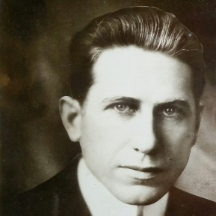

James Oliver Curwood
James Oliver Curwood was born here in Owosso in the back of his father’s cobbler shop. He started writing at the age of nine on any scrap of paper he could find. As he grew up so did his stories. His little short stories grew up into adult action - adventure novels. In the age before television, books were the staples of entertainment for families. Mr. Curwood’s stories, containing such characters as Canadian Mounties & wild animals, were set in the Yukon, Canada, & Alaska were highly anticipated. There were over 230 movies that were made from his stories.

He built Curwood Castle in 1923 as his writing studio. Here he would write his stories, work on his conservation work, & meet with his publishers and editors. He wrote 33 books and hundreds of short stories. In the 1920’s he was the highest paid author (per word) in the world and was the first author to make over a million dollars. Even though Curwood could have lived anywhere he wanted to, he chose to live in Owosso. He said “Owosso is the nicest place in the world”.

Curwood died in 1927 after a short illness. His books were still being made into movies as recently as 1989. In Canada some of his books are still required reading for schoolchildren. A boy born here in Shiawassee County grew up to be one of the best known authors in the world. And you can follow in his footsteps.

Let’s keep the legacy of James Oliver Curwood alive.

Curwood Saga Writing Contest Rules

This writing contest is to promote an interest in school age children to write and to help keep the memory of James Oliver Curwood alive. The contest is open to all schoolchildren of public, parochial, and home schooled students 4th through 12th grade in Shiawassee County.

Stories should be written in the Curwood style. Mr. Curwood wrote stories about the wilderness and man’s connection to the wilderness. He was interested in conservation and hunting. He wrote about the animals that inhabited the wild.

Your stories should use a 12 point font of your choice and have margins of no more than one inch on each side. They should be typed. You will be judged on grammar, spelling, punctuation, style, and originality.

Stories are due in by May 1st and should be original work. You can download an entry form from the Curwood Festival website and one must be included with your entry. Contest judges retain the right to refuse entries that do not meet the submission criteria. Winners will be notified by email or telephone.

Elementary Division includes grades 4th & 5th. Your stories need to be between 2 and 4 pages long.

The Middle School division is for grades 6th, 7th, and 8th. Your stories should be between 4 and 8 pages long.

The High School division includes grades 9th, 10th, 11th, and 12th. Your stories should be between 5 and 12 pages.

There will be a first and second prize winner for each grade division. Prizes vary from year to year.

All prize winners will be presented to the Curwood Festival board meeting if possible and will also have a chance to ride in the Curwood children’s parade.

All stories become the property of the Curwood Festival.
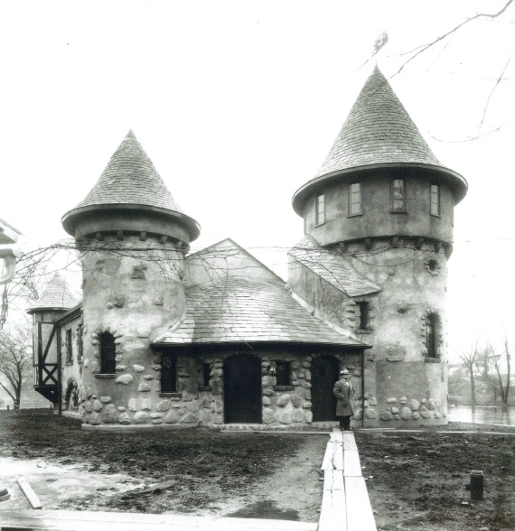

Most of all we want you to have fun
with this!

If you have any questions please email
denicegrace@msn.com or please call Curwood Castle at 989-723-2155 between the hours of 1 p.m. and 5 p.m. Tuesday through Sunday

If you mail your story, please address it to: attention Curwood Festival Saga Writing Contest. Stories may not be submitted by email.

Stories may be dropped off or mailed to any of the following locations:

The Curwood Festival Office - 212 S. Washington St. Owosso, MI 48867 open Tuesday through Thursday 10:30a.m. – 2:30 p.m.

Shiawassee District Library - Owosso Branch-502 W. Main St. Owosso 48867 – during normal business hours

Shiawassee District Library-Durand branch-700 N. Saginaw Street Durand, MI 48429 – during normal business hours

A quote from The Sons of the Forests an autobiography written by James Oliver Curwood

“Tonight I am in a little cabin in the heart of a great wilderness. Outside it is dark. I can hear the wind sighing in the thick spruce tops. I hear the laughter of a stream out of which I took my supper of trout. The People of the Night are awake, for a little while ago I heard a wolf howl, and, not far away, in an old stub, lives an owl that hoots at the light in my window. I think it’s going to storm. There is heaviness in the air, and, in the drowse of it, the sweetness of distant rain….I am strangely contented as I start writing… “

Curwood Saga
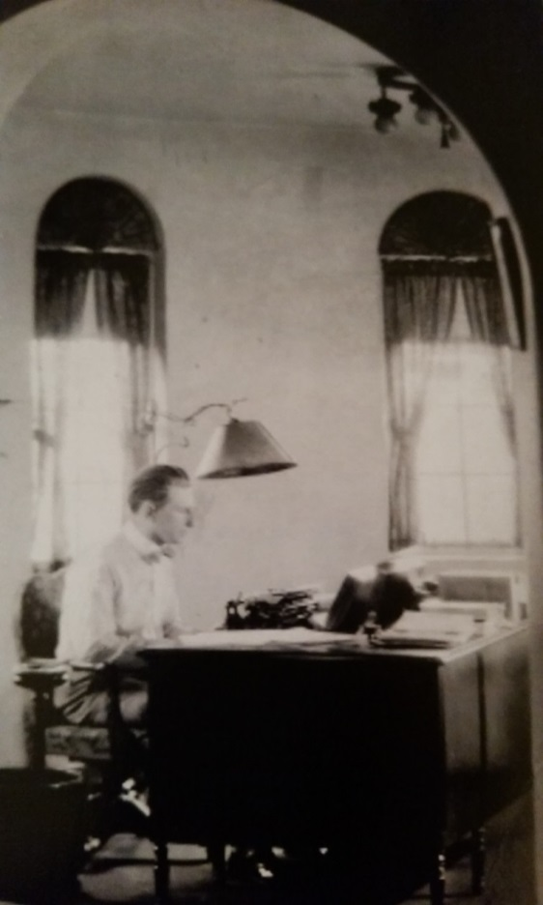
Writing Contest

