Curwood Festival
Curwood Saga Writing Contest
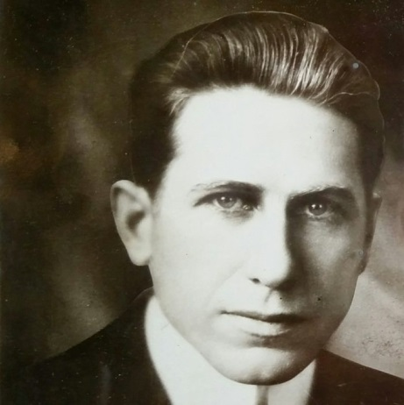

For public, parochial, and home schooled students in grades 4th – 12th

Stories should be written in the style of James Oliver Curwood who wrote about nature and man’s connection to the wilderness.

There are three divisions:
Elementary is for grades 4th & 5th and stories should be 2 -4 pages long

Middle school which is 6th -8th grades and stories should be 4-8 pages long

High School which is grades 9th – 12th and stories should be between 5-12 pages long.

There will be a first and second prize awarded in each category

An entry form must accompany every entry and can be downloaded from the Curwood Festival website.

You will be judged on grammar, spelling, punctuation, style, and originality.
Stories may be dropped off at the Curwood Festival Office, Curwood Castle, & both the Owosso and Durand branches of the Shiawassee District Library

Deadline is May 1st
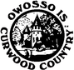
Email denicegrace@msn.com for details

Prizes vary from year to year

Good luck!

